**KALI LINUX:**

Kali Linux is a free, open-source Linux operating system designed specifically for:

Cybersecurity, Ethical hacking, Penetration testing, Digital forensics. It is developed and maintained by Offensive Security.

**NMAP:**

Nmap (short for Network Mapper) is a powerful open-source network scanning tool used for:

✅ Discovering devices on a network  
✅ Scanning ports and services  
✅ Identifying operating systems  
✅ Detecting vulnerabilities (with scripts)  
✅ Network auditing and troubleshooting

**Use Nmap in Kali Linux to find and scan Metasploitable’s IP address.**

CLI: nmap 192.168.91.129 (metasploitable ip address)

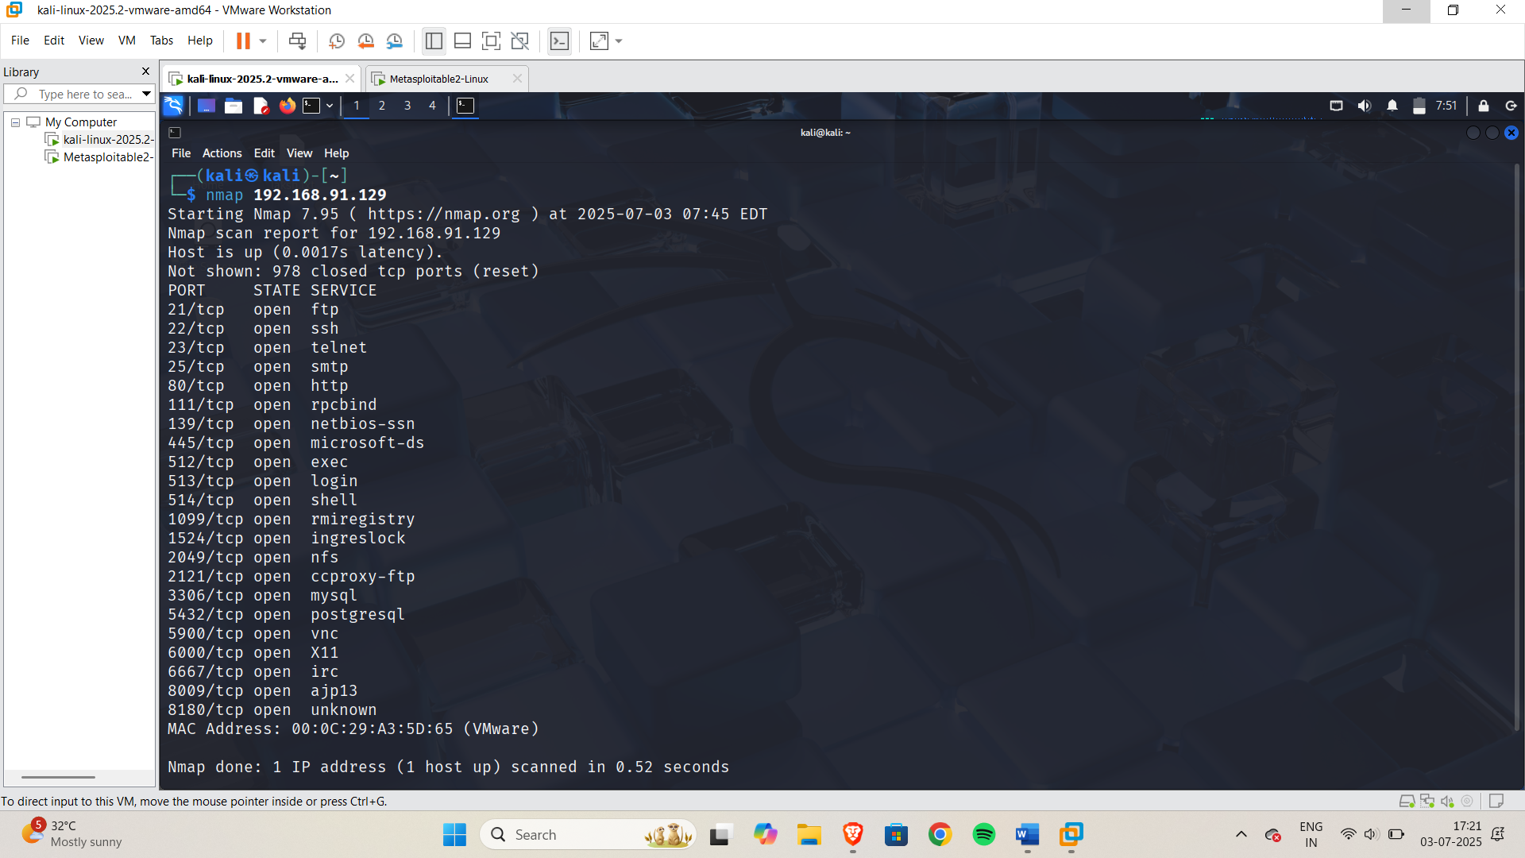

**Then use -sV stand for Service Version Detection, this command will scan the target IP and output something like:**

CLI: Nmap -sV 192.168.91.129

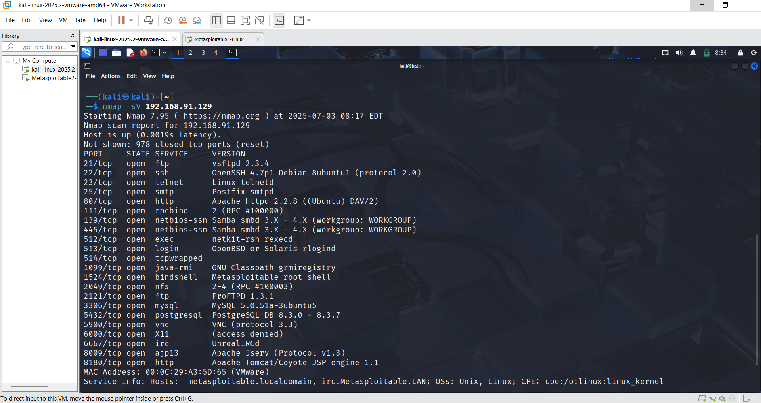

**What is msfconsole**

msfconsole is the main command-line interface for the Metasploit Framework, one of the most powerful and widely used tools for:

* ✅ Ethical hacking
* ✅ Penetration testing
* ✅ Exploitation of vulnerabilities
* ✅ Security research

It provides access to all features of Metasploit, including modules for exploits, payloads, auxiliary scanners, and post-exploitation tools — all in one terminal.

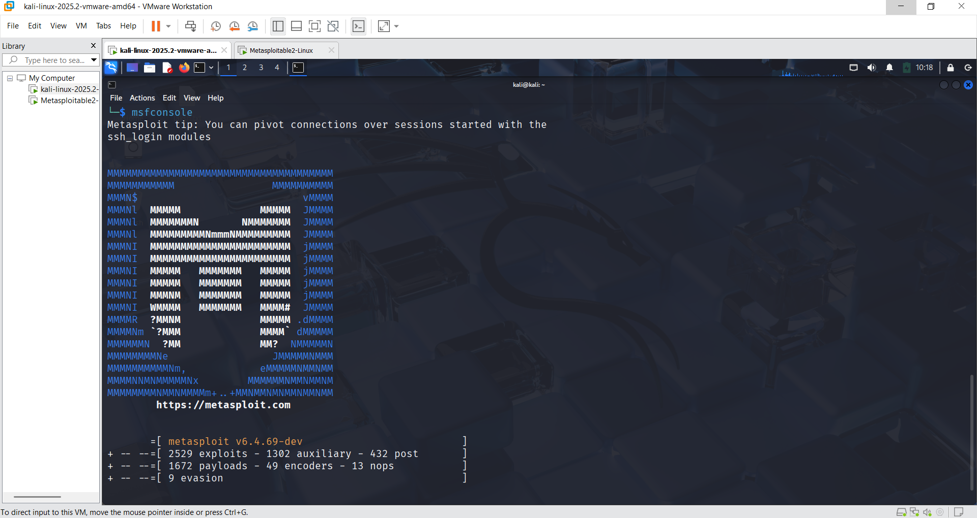

**FTP:**

FTP stands for File Transfer Protocol. It is a standard network protocol used to transfer files between two computers over a TCP/IP network (like the Internet or a LAN).

After that, Search for FTP Exploits then find and match the FTP version

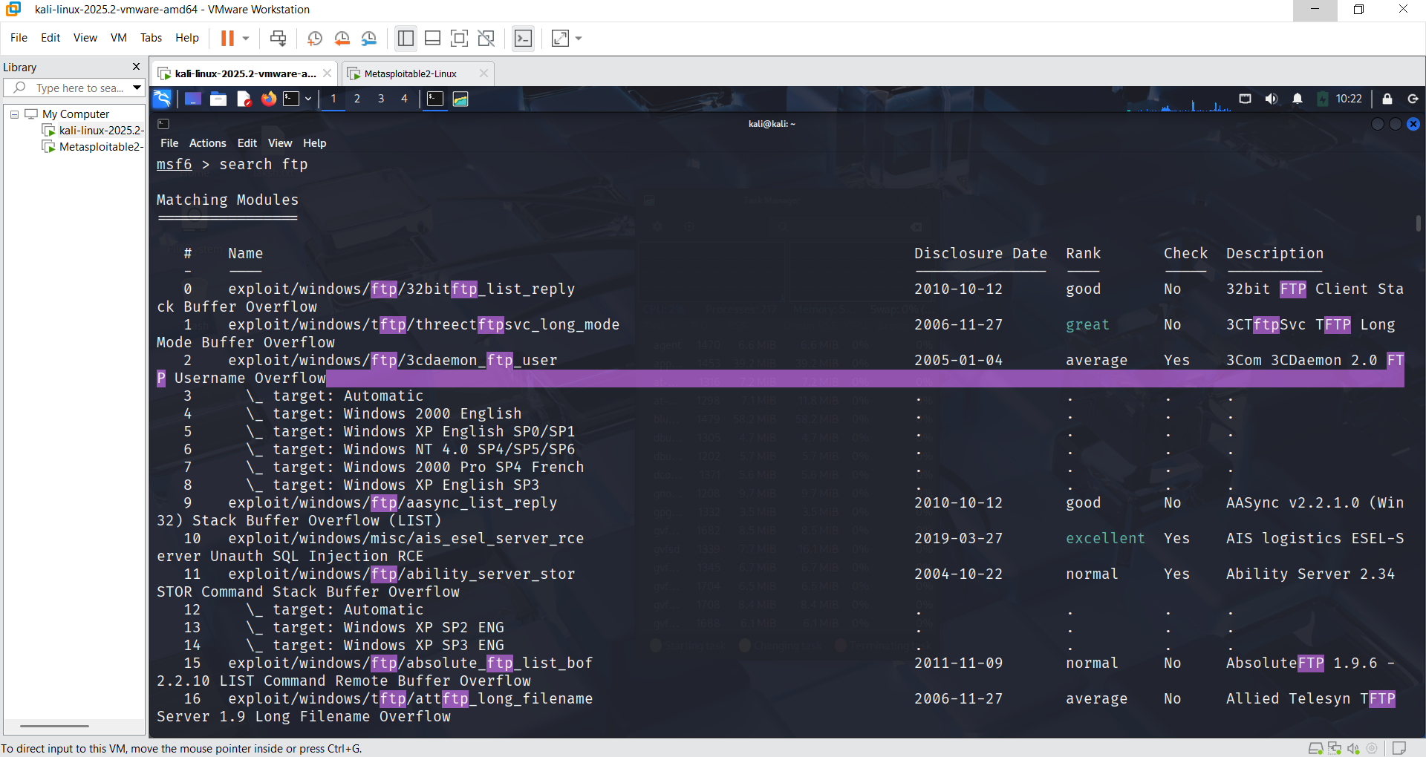

**Use module 494, where we can find the same version of the FTP service.  
Then, type options to view the available module settings, which include multiple configurable options.**

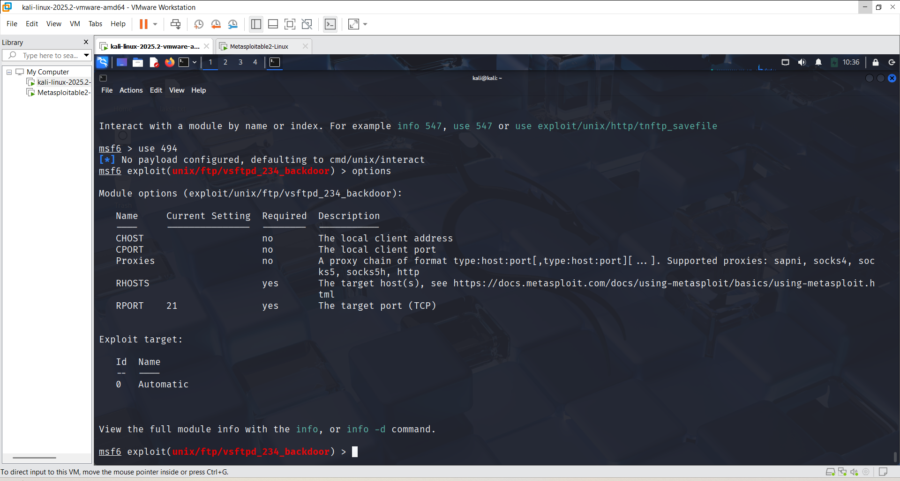

**You need to fill in the details for all options that are marked as required: yes.**

In RHOSTS set target IP Address

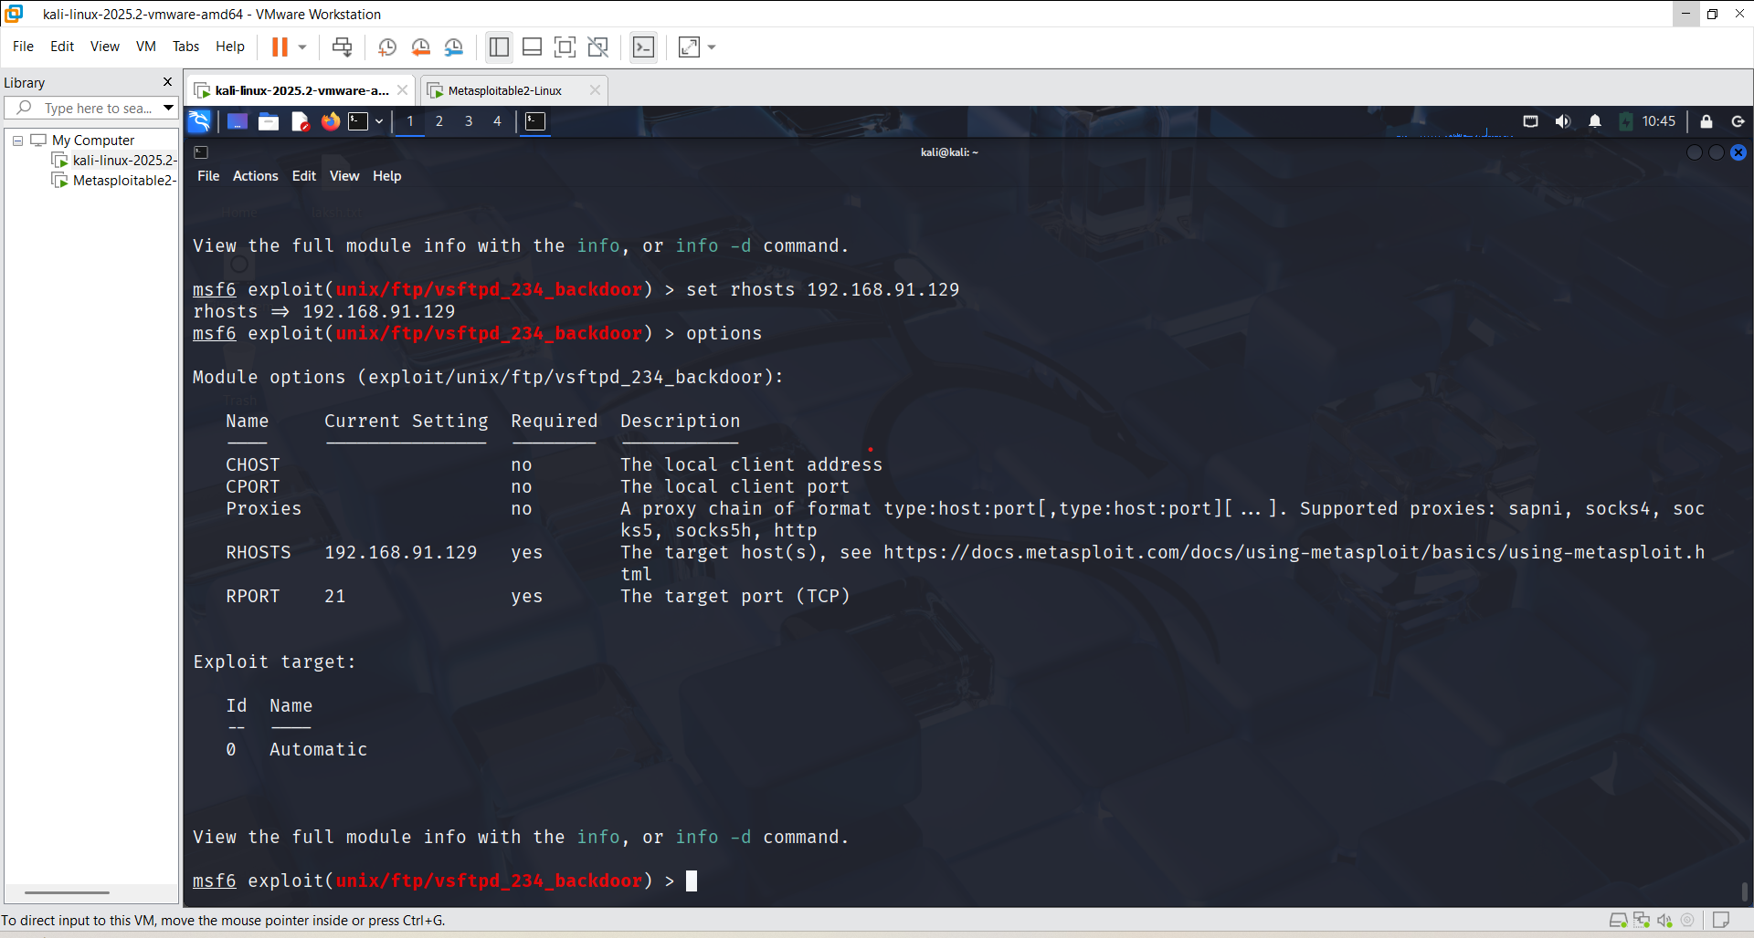

Then RUN

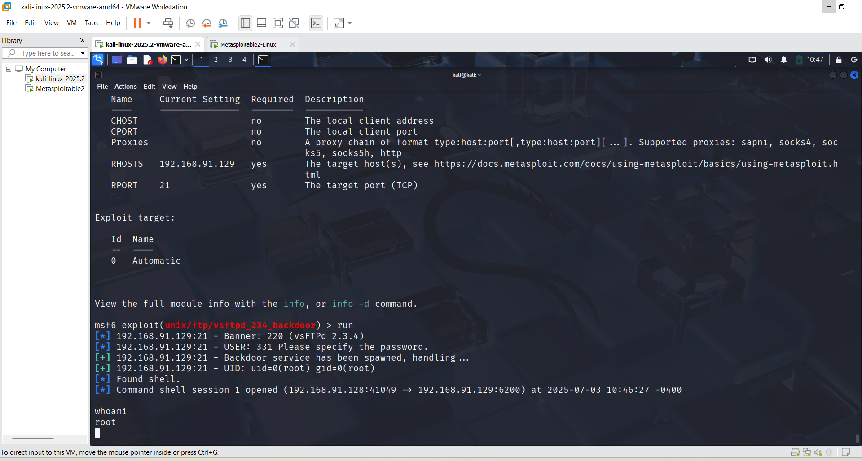

After that, you can access the Metasploitable system and explore or check various services and vulnerabilities.

This the kali view and

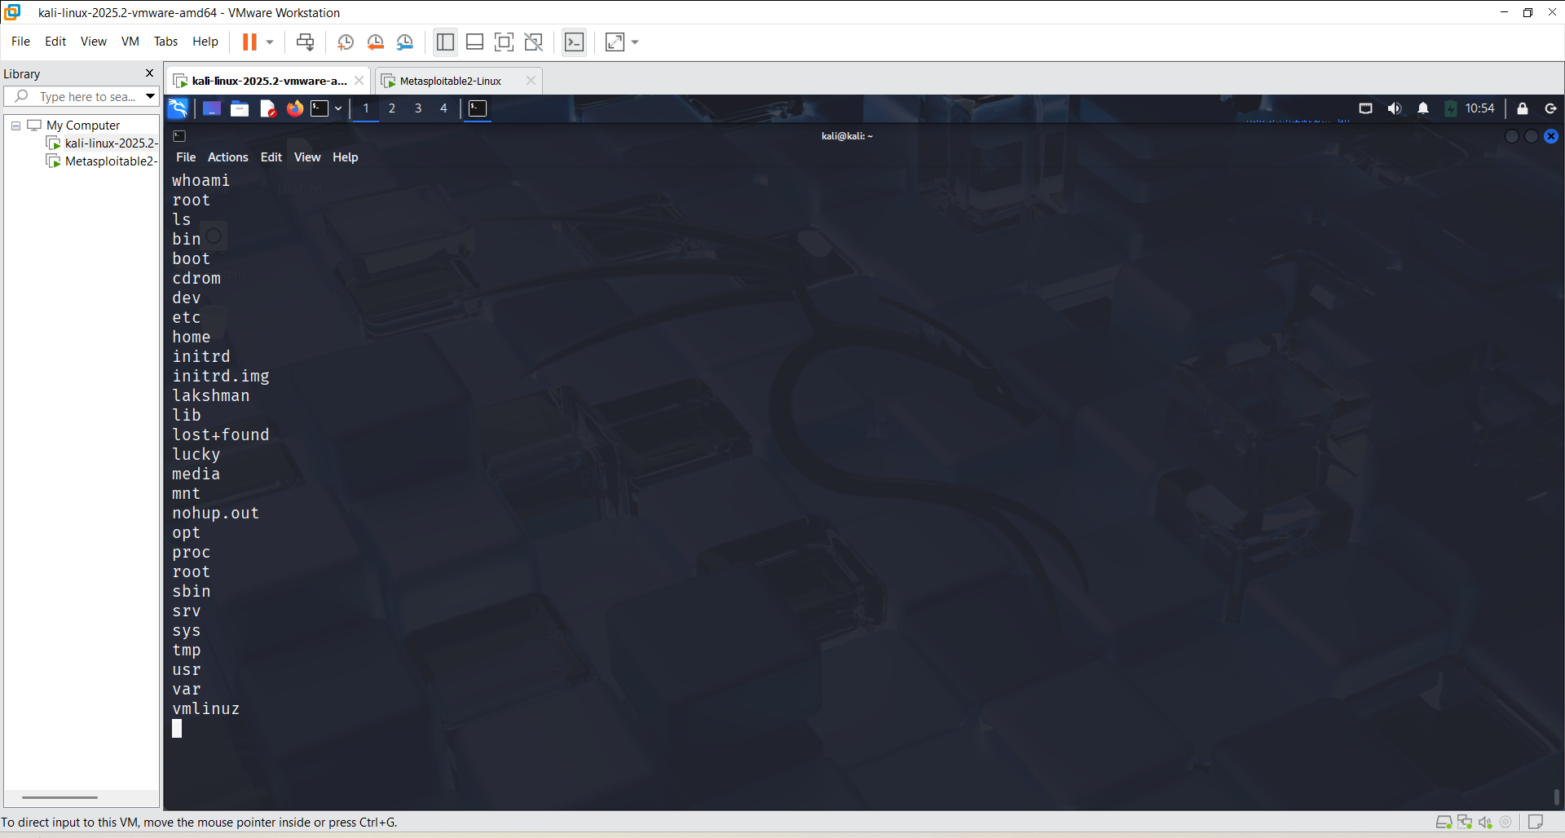

And this is Metasploitable view, both data are same that means you can access the metasploitable

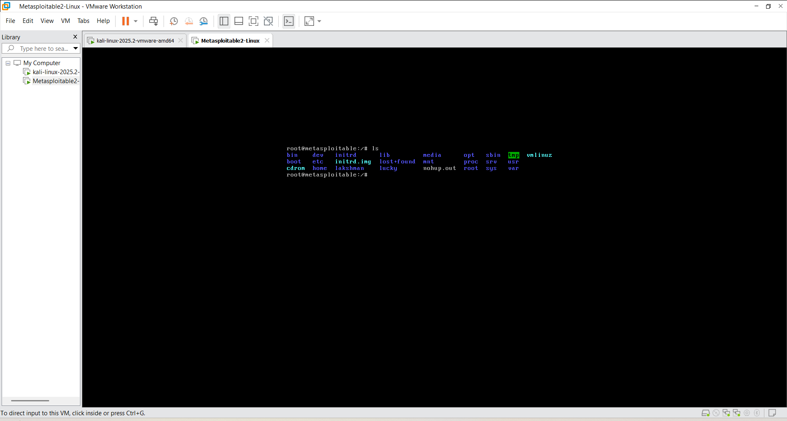

**SSH:**

SSH means **Secure Shell**. It is a way to **safely connect** to another computer (like a server) using the internet.

**🔧 What You Can Do with SSH:**

1. **Login to another computer** (from anywhere)
2. **Run commands** on that computer
3. **Transfer files** between your computer and the remote one
4. **Manage servers** (used a lot by developers and admins)

CLI : nmap -sV 192.168.91.129

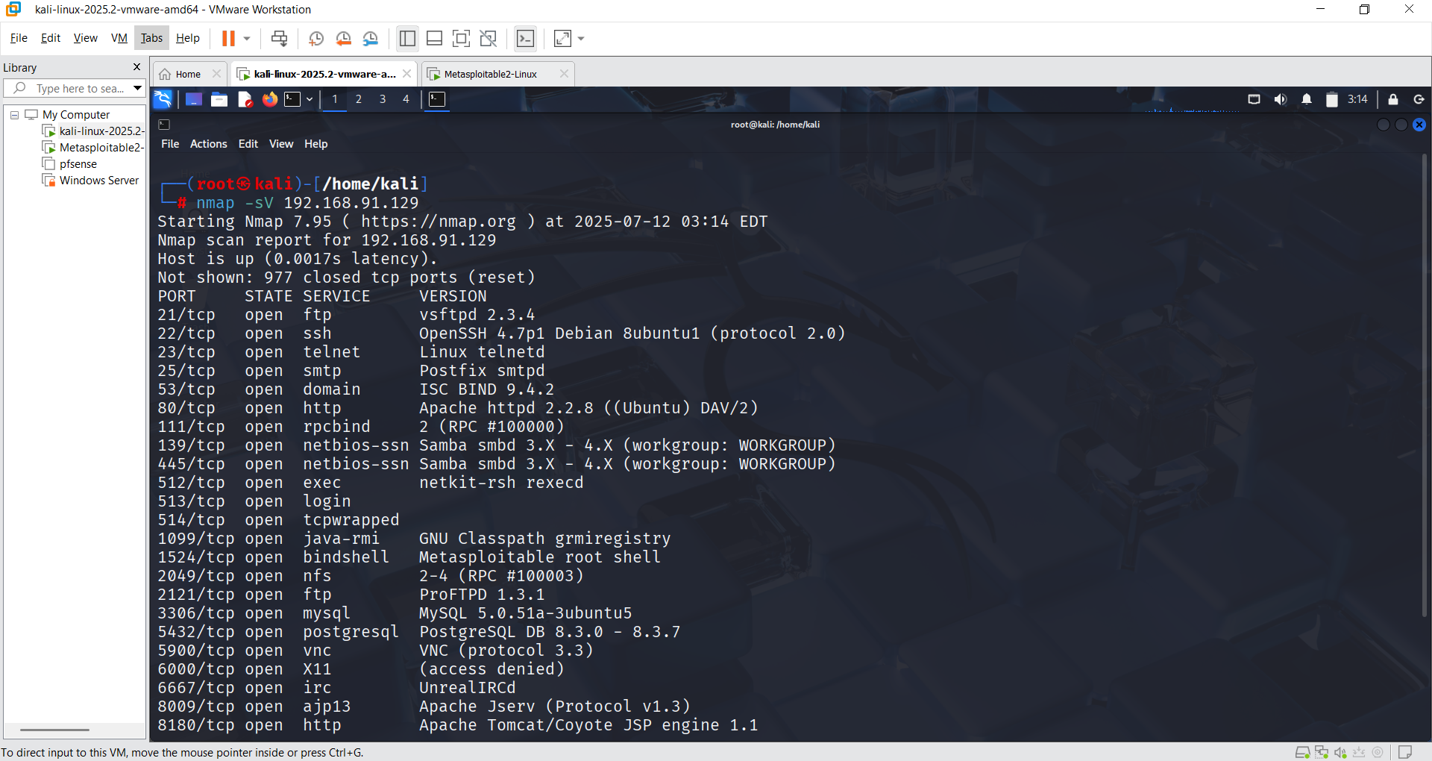

**What does msfconsole perform?**

msfconsole is a tool used in **ethical hacking**. It performs:

1. ✅ **Finds weak points** in computers (vulnerabilities)
2. 💥 **Attacks the system** (only for testing)
3. 🎯 **Sends a payload** (like a reverse shell to control the target)
4. 🕵️ **Collects information** (IP, ports, services)
5. 🛠️ **Gives control** of the target computer
6. 📄 **Makes reports** after testing

msfconsole is used to **test how safe a system is** by performing hacking activities **in a legal way**.

CLI: msfconsole

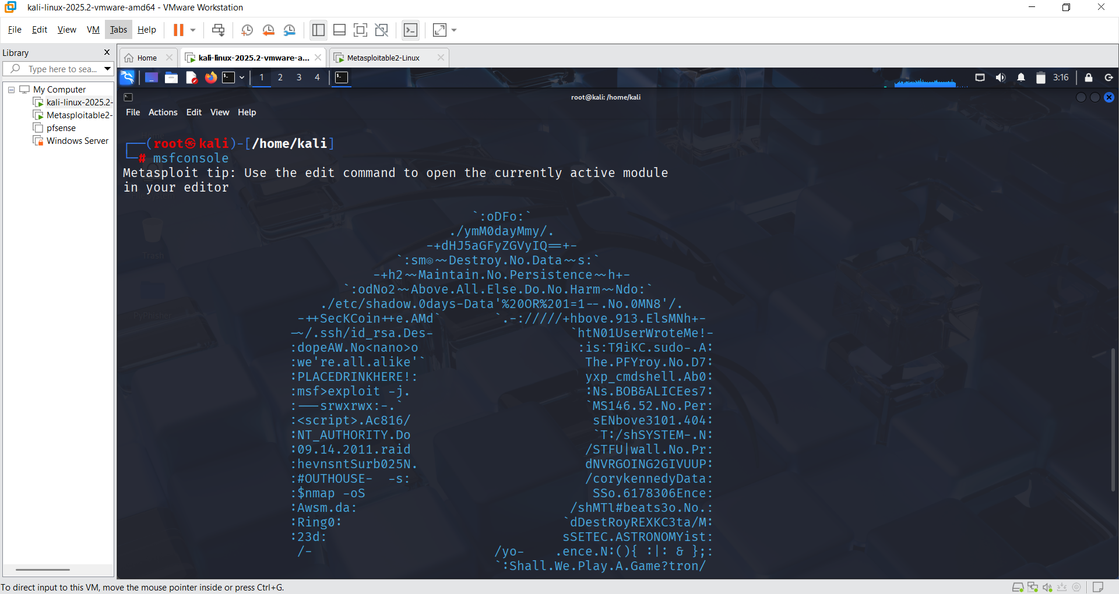

Search ssh

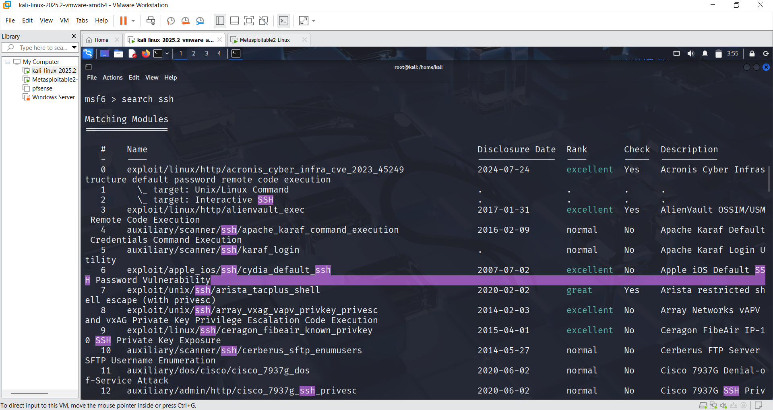

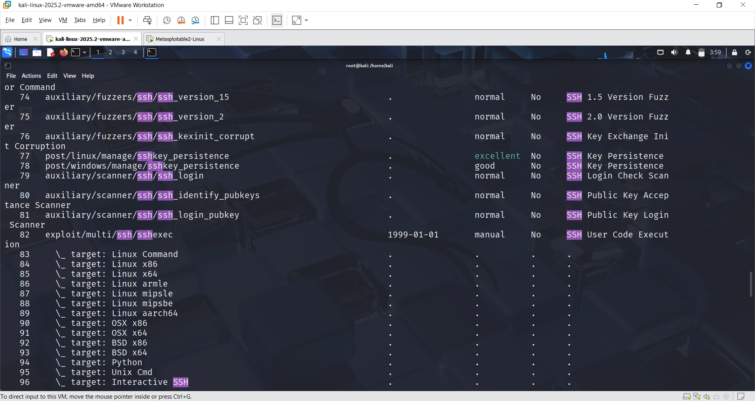

Use 79 and then options

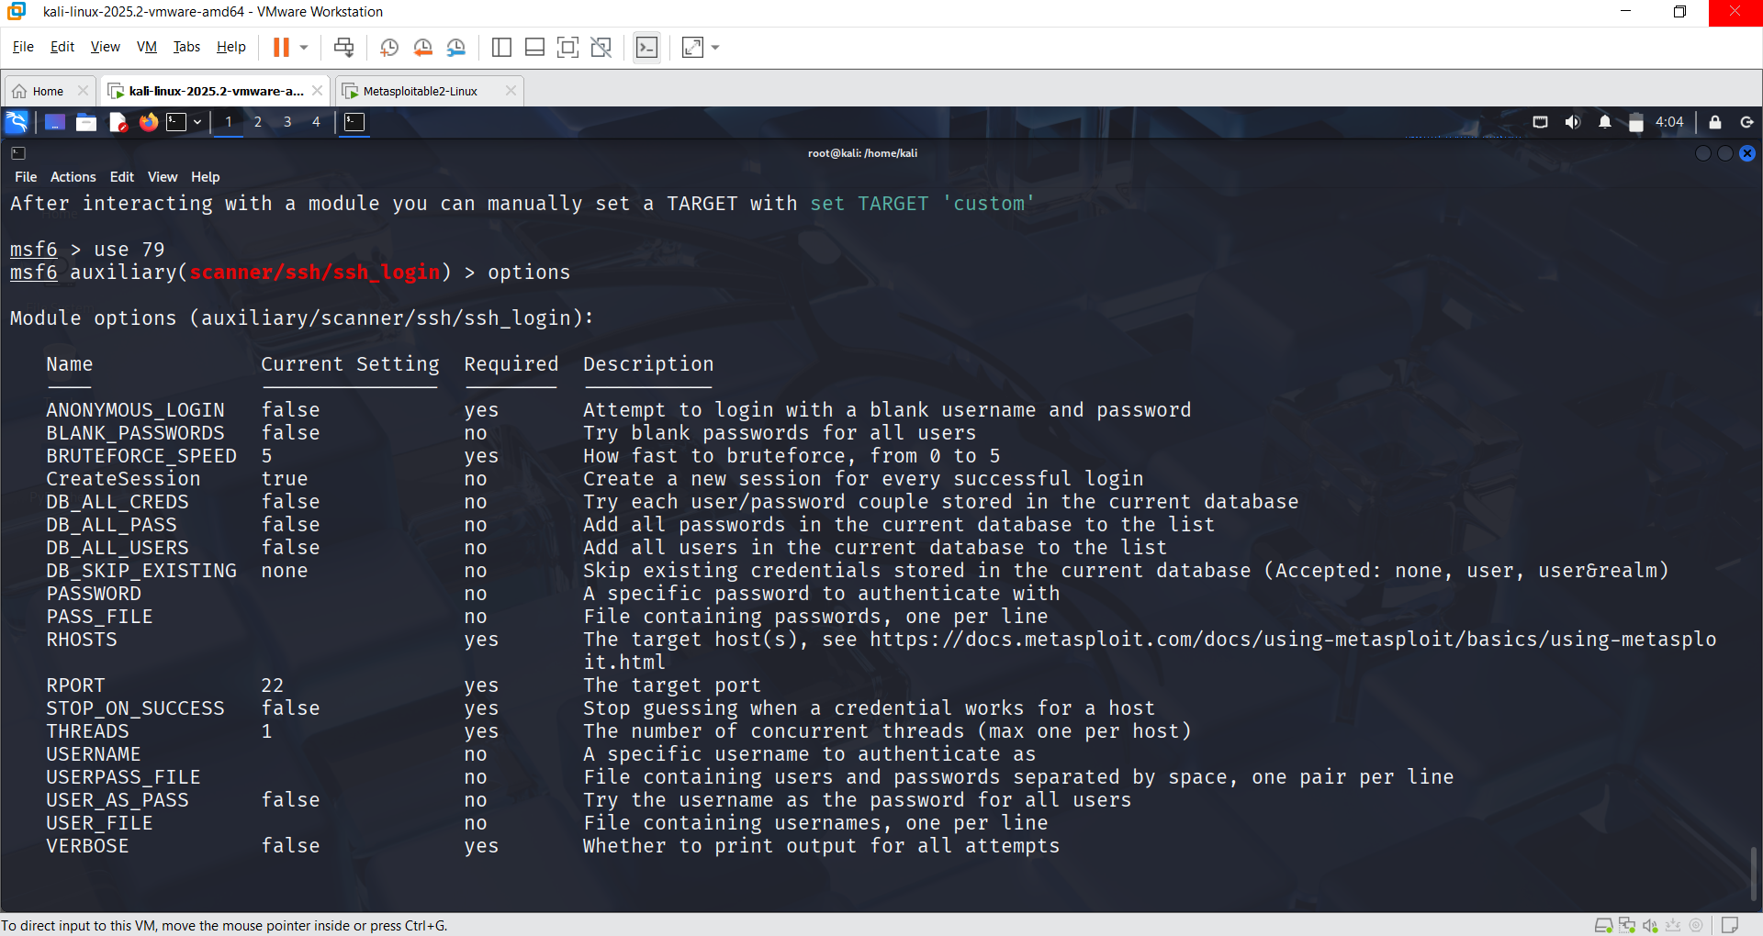

After that set rhosts ( IP Address of metasploitable ), then

Set STOP_ON_SUCCESS true

After that go to the new terminal and create a pass.txt and user.txt , set PASS_FILE (path address of pass.txt ) /home/kali/pass.txt and set USER_FILE (path address of user.txt ) /home/kali/user.txt

After that set VERBOSE true

| **Command** | **Description** |
| --- | --- |
| set RHOSTS 192.168.91.129 | Sets the target IP (Metasploitable IP) |
| set STOP_ON_SUCCESS true | Stops the scan once valid credentials are found |
| set PASS_FILE /home/kali/pass.txt | Path to the password wordlist file |
| set USER_FILE /home/kali/user.txt | Path to the username wordlist file |
| set VERBOSE true | Enables detailed output in the console |

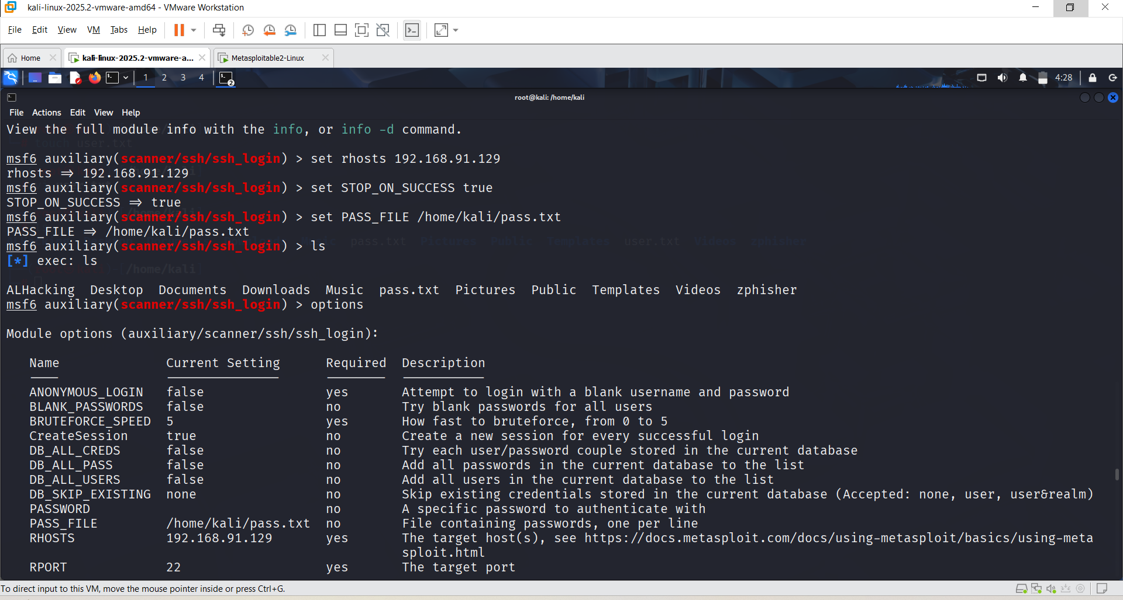

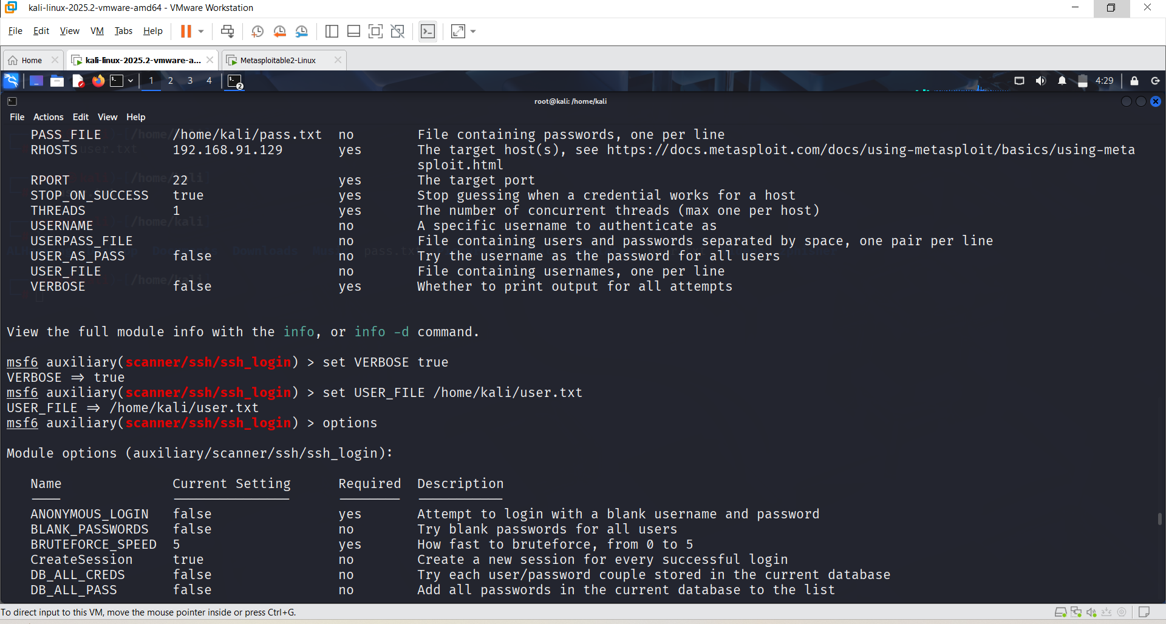

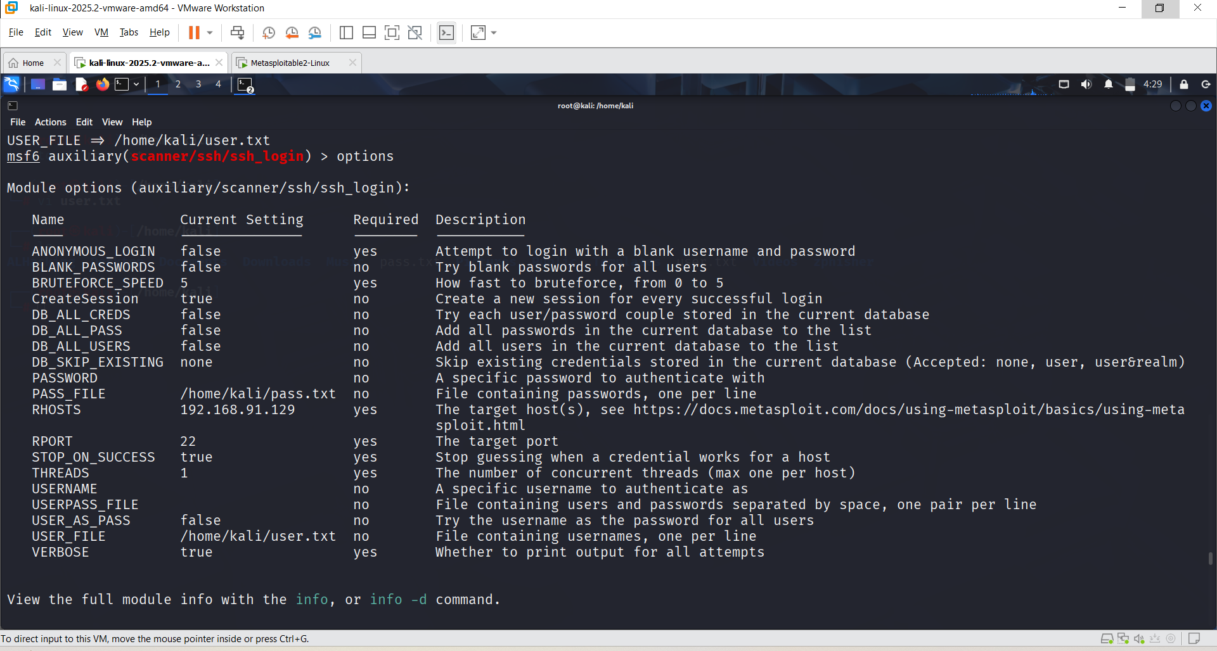

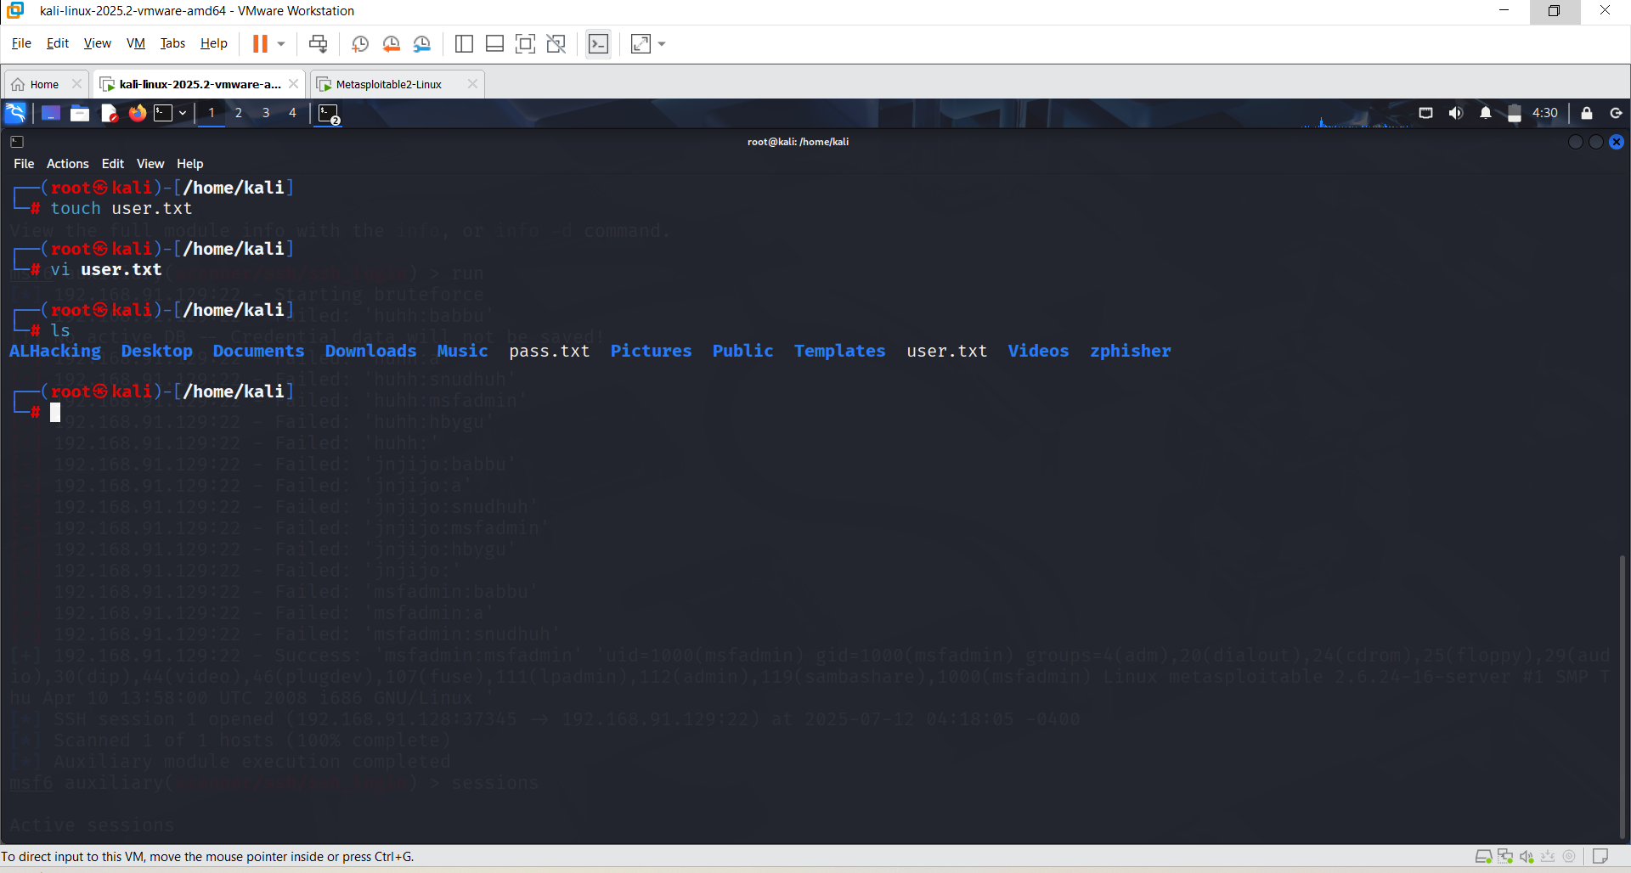

**Run/Exploit**

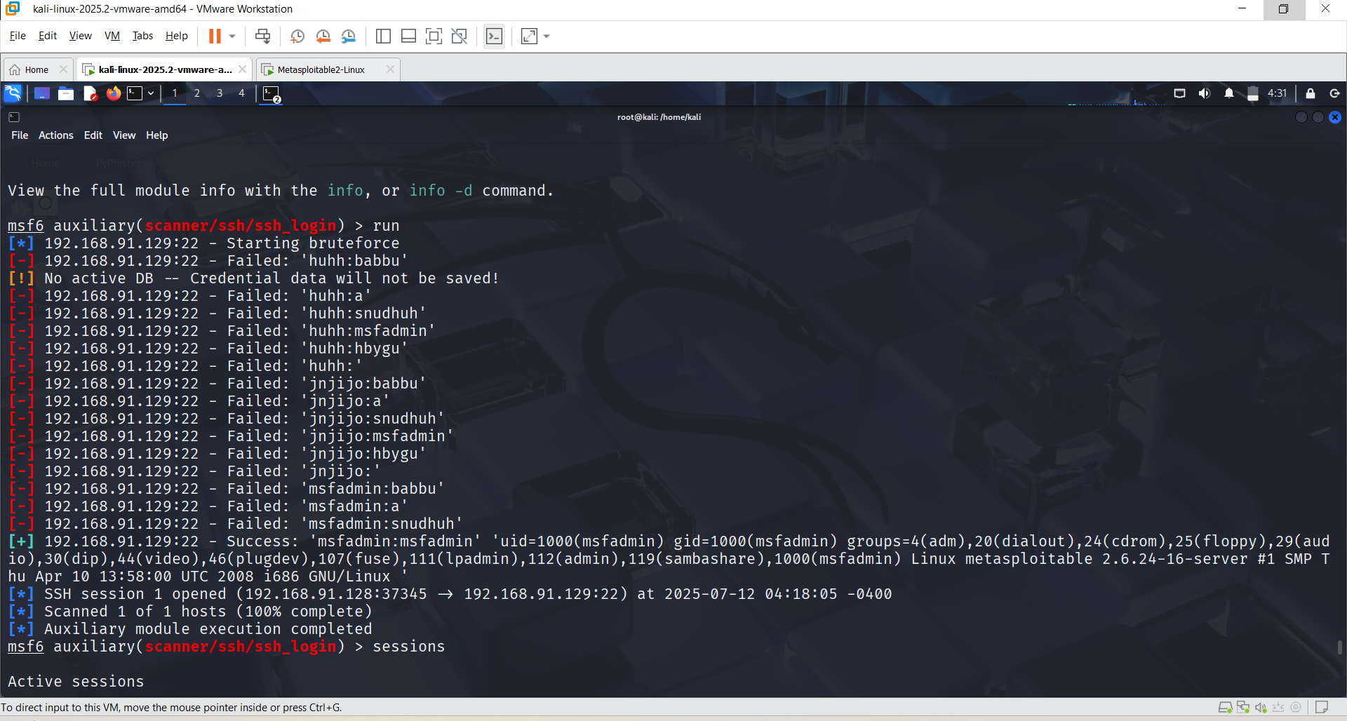

**Sessions**

When you exploit a system and it works, Metasploit gives you a session so you can:

* Access files, Run commands, Control the system, Take screenshots, record webcam, etc. (with permission!)

After that session 1,

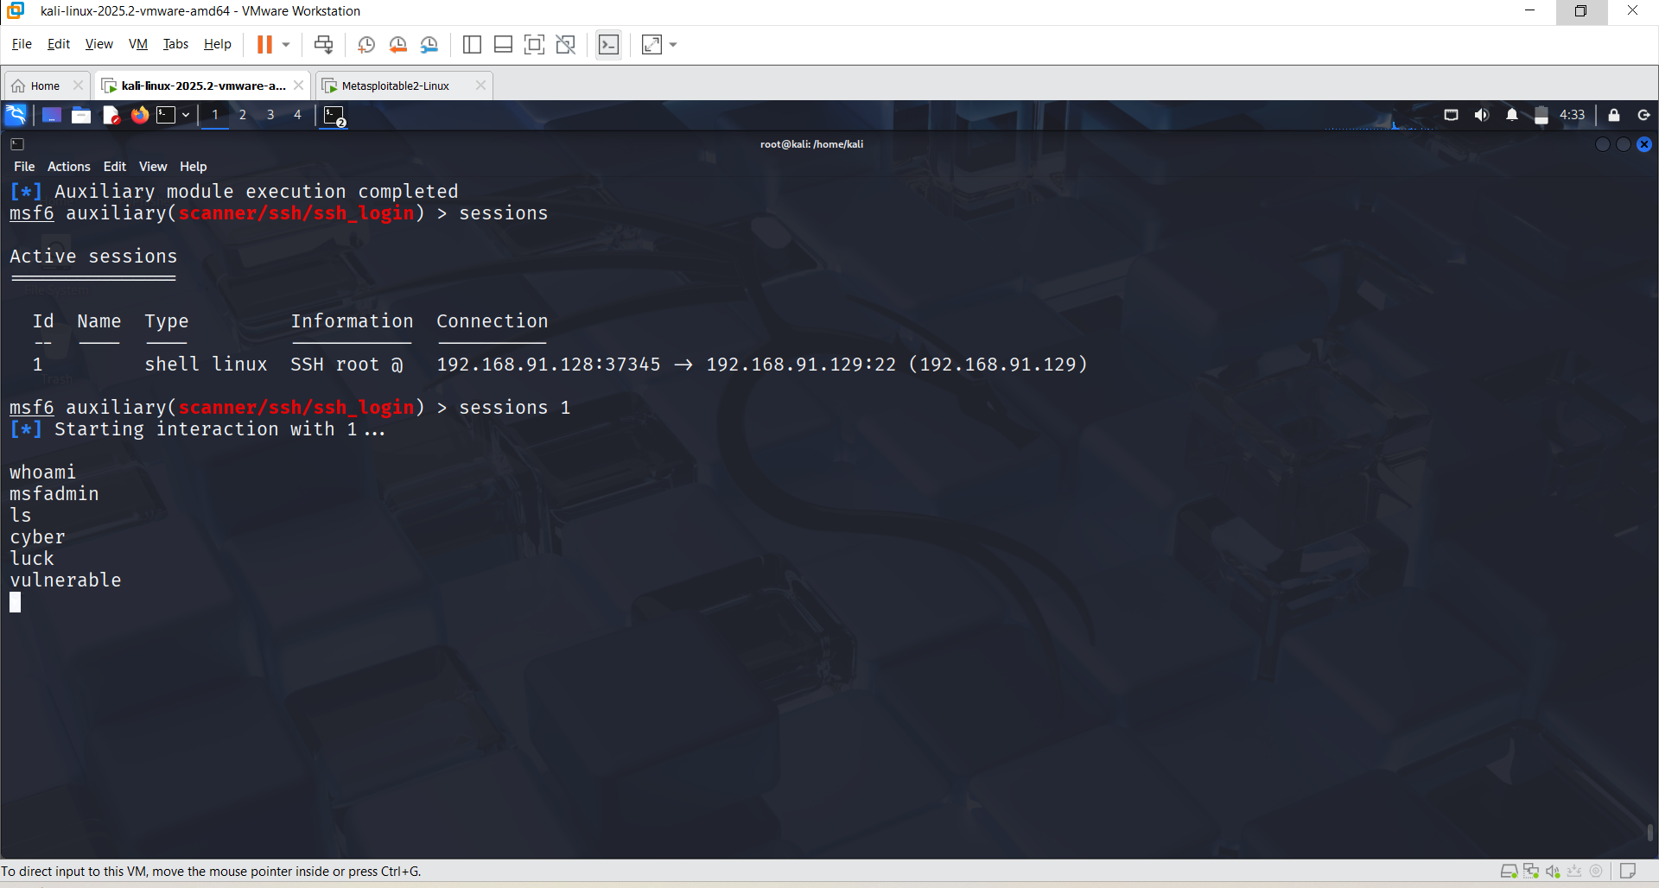

**It is clearly observed that Metasploitable is easily accessible once exploited using Metasploit. The attacker can gain full control over the system, allowing them to modify system settings, access or change files and documents, and perform various post-exploitation tasks without any restrictions.**

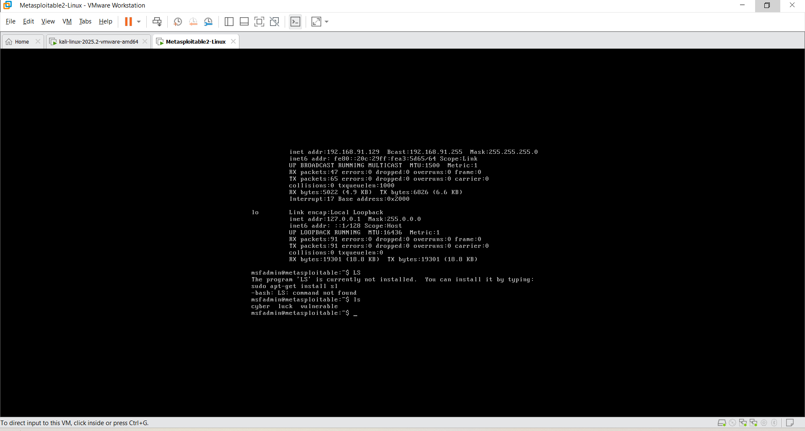

**The data clearly indicates that Metasploitable is fully accessible once exploited. This means an attacker can easily gain access, view, modify, or delete any files and system data, demonstrating how vulnerable the system is without proper security measures.**

**Telnet:** Telnet is a network protocol used to connect to remote computers over a command-line interface.

Telnet lets you log in to another computer remotely and run commands — like you’re sitting in front of it.

**What Telnet Can Do:**

* Remote login to servers
* Check if ports are open
* Test services (like mail, web, FTP)
* Send basic commands to the target

**CLI: nmap -sV -O 192.168.91.129 ( V- Version and O- Operating System)**

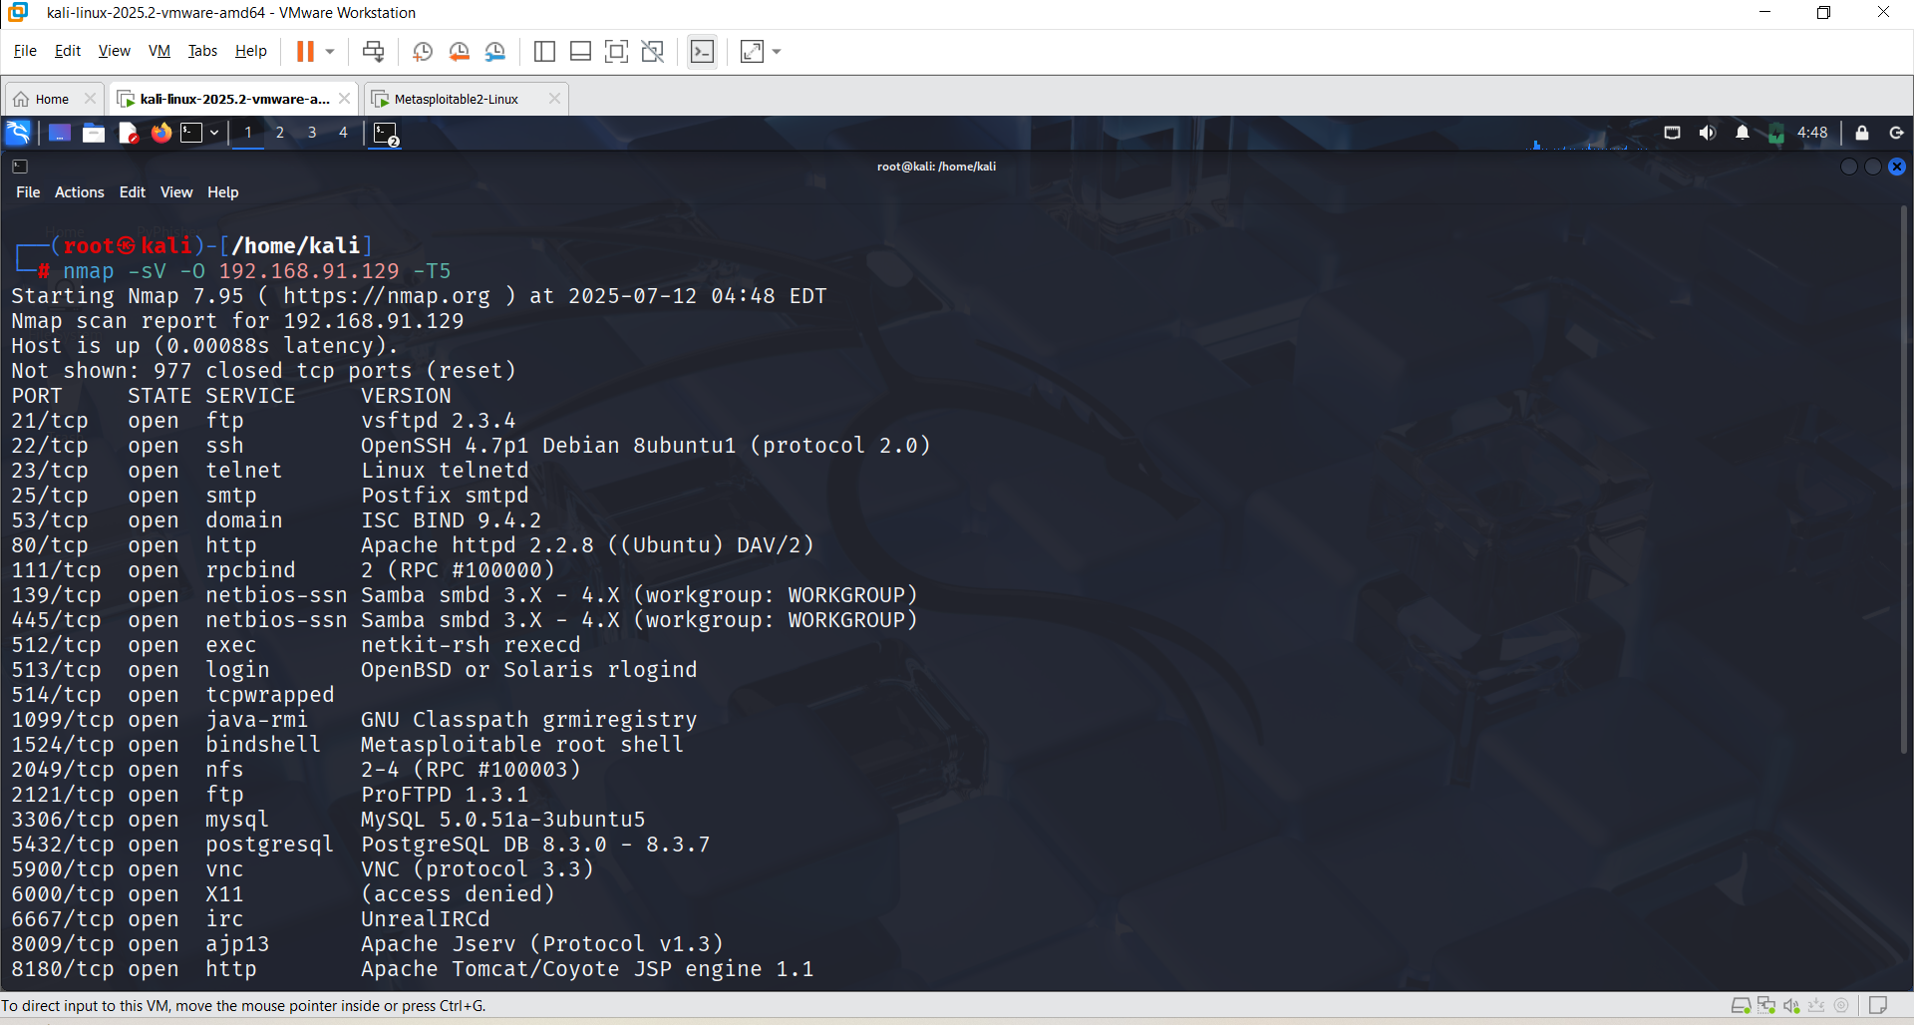

**CLI: msfconsole**

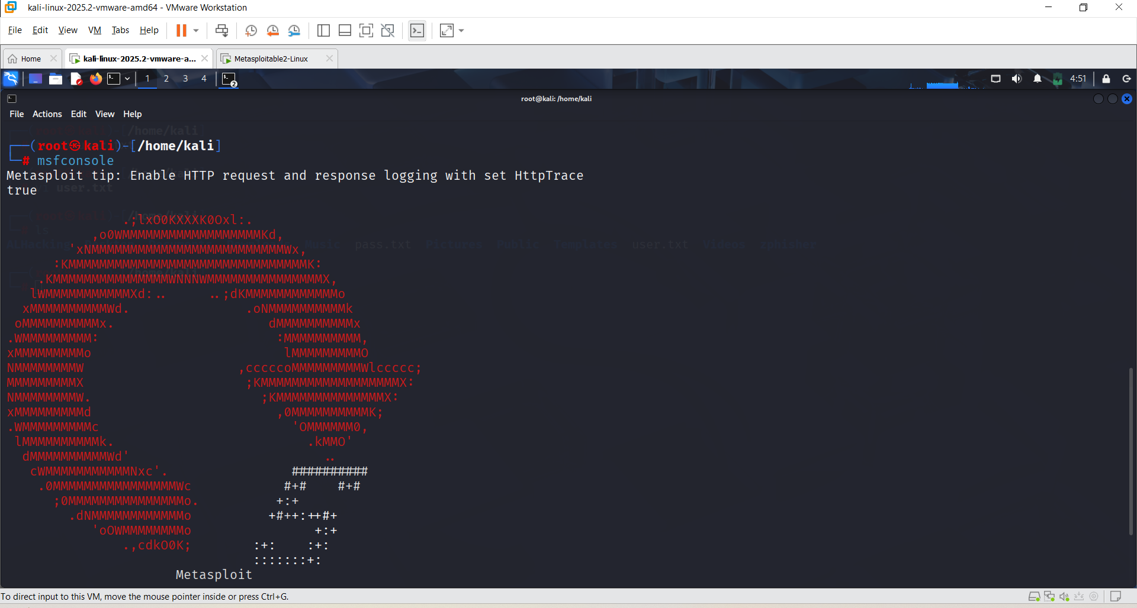

**CLI: search telnet**

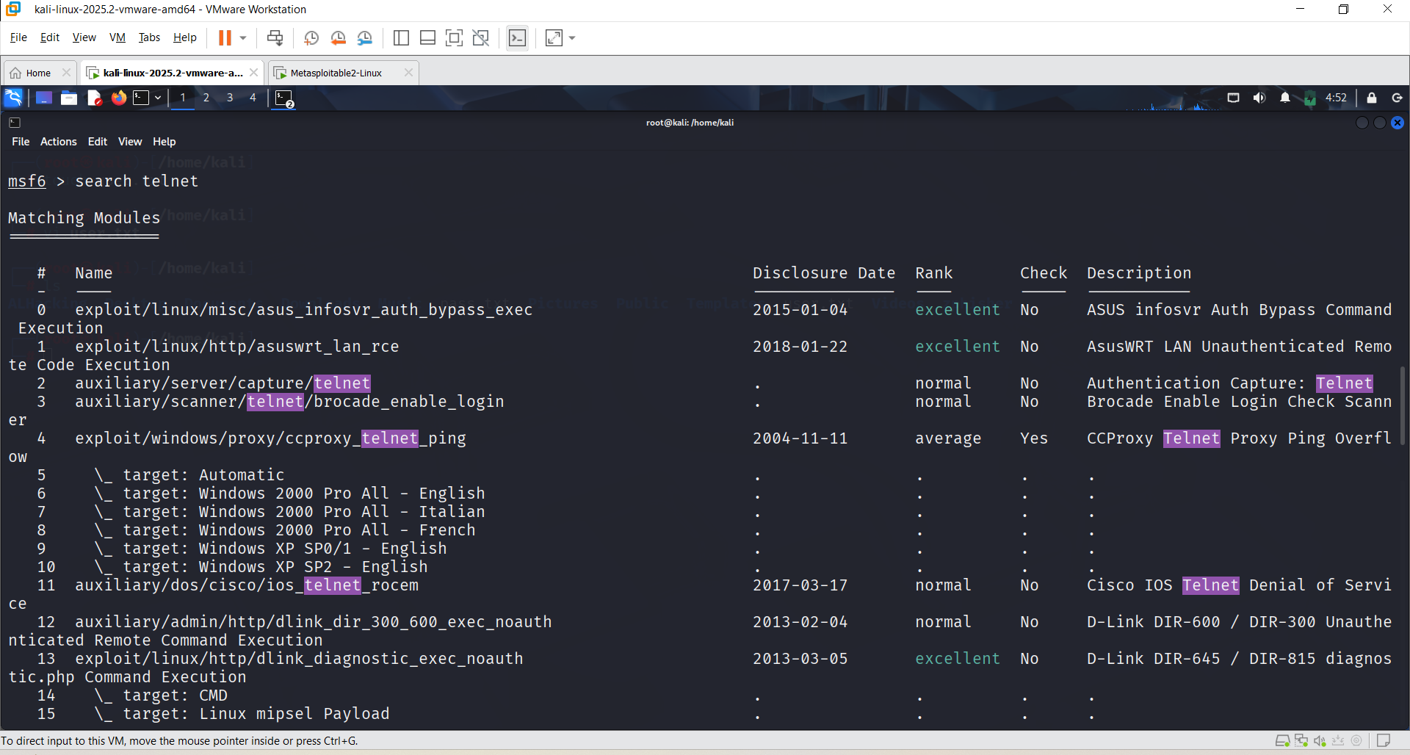

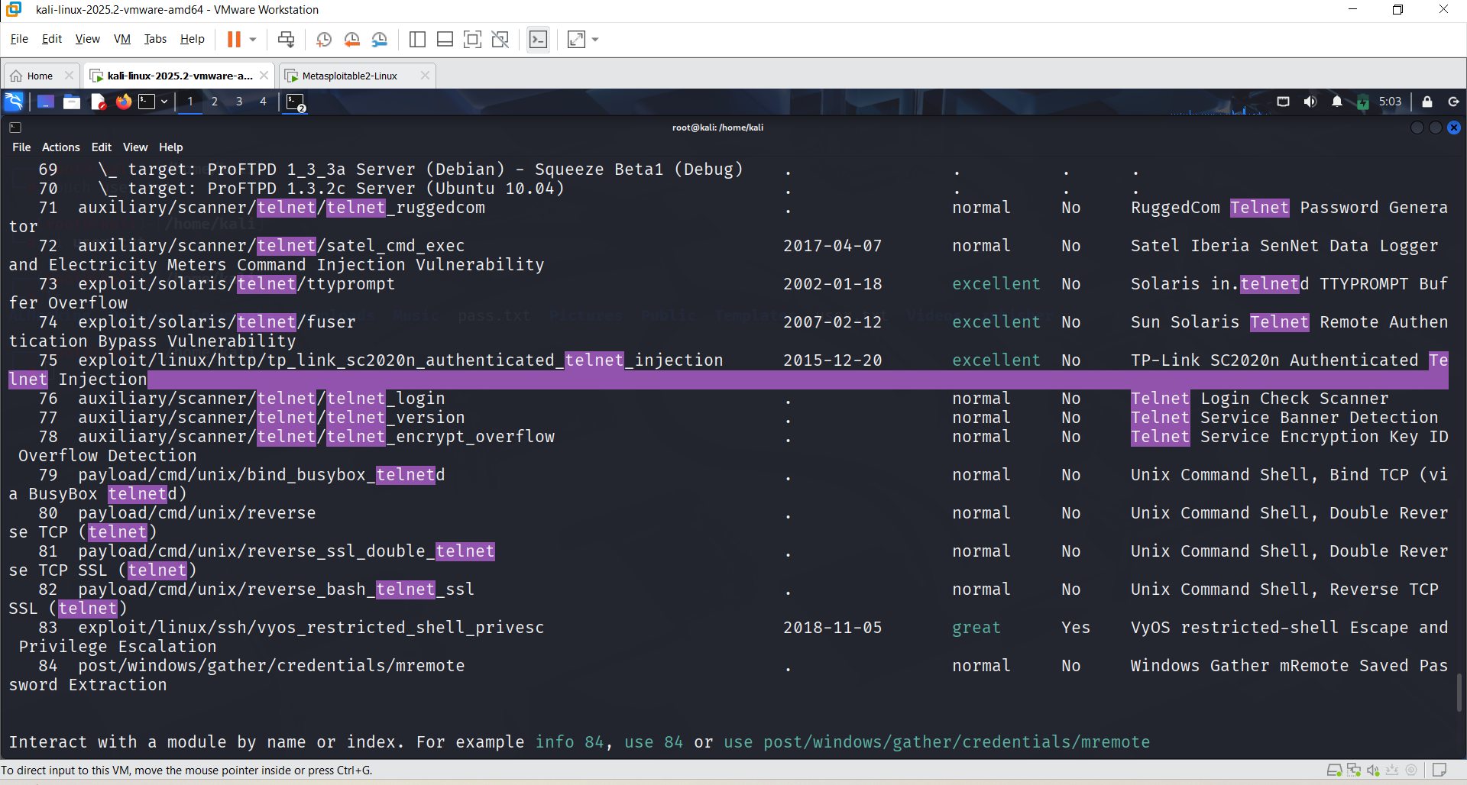

**Use 76 and options**

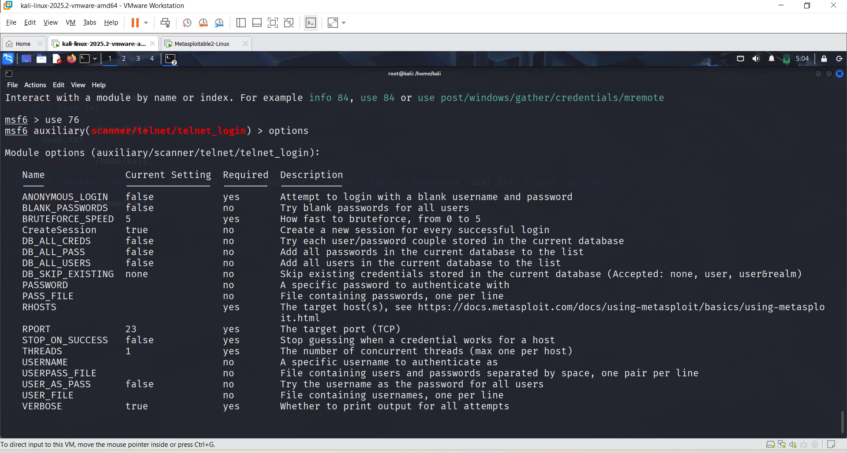

After that set rhosts ( IP Address of metasploitable ), then

Set STOP_ON_SUCCESS true

After that go to the new terminal and create a pass.txt and user.txt , set PASS_FILE (path address of pass.txt ) /home/kali/pass.txt and set USER_FILE (path address of user.txt ) /home/kali/user.txt

| **Command** | **Description** | |
| --- | --- | --- |
| set RHOSTS 192.168.91.129 | | Sets the target IP (Metasploitable IP) |
| set STOP_ON_SUCCESS true | Stops the scan once valid credentials are found | |
| set PASS_FILE /home/kali/pass.txt | Path to the password wordlist file | |
| set USER_FILE /home/kali/user.txt | Path to the username wordlist file | |
| set VERBOSE true | Enables detailed output in the console | |

**After that run/exploit**

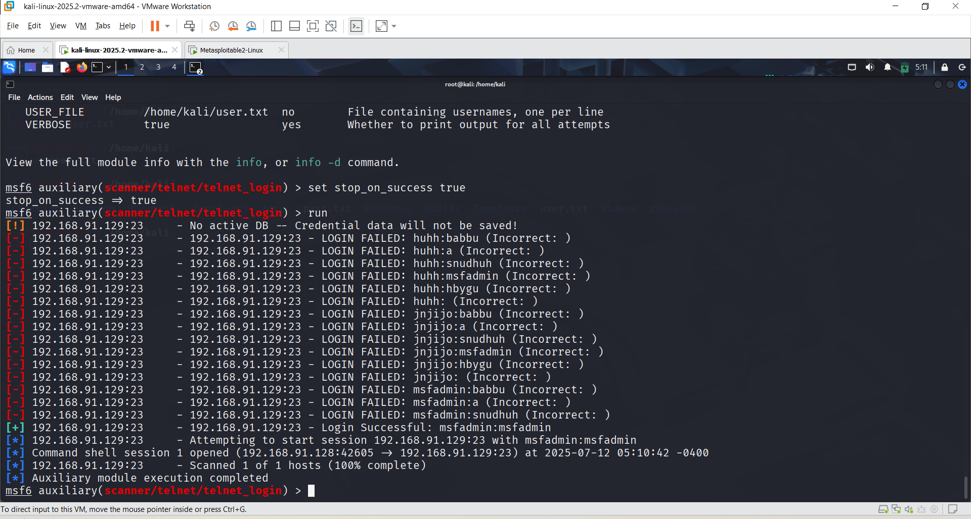

**Sessions after that session 1**

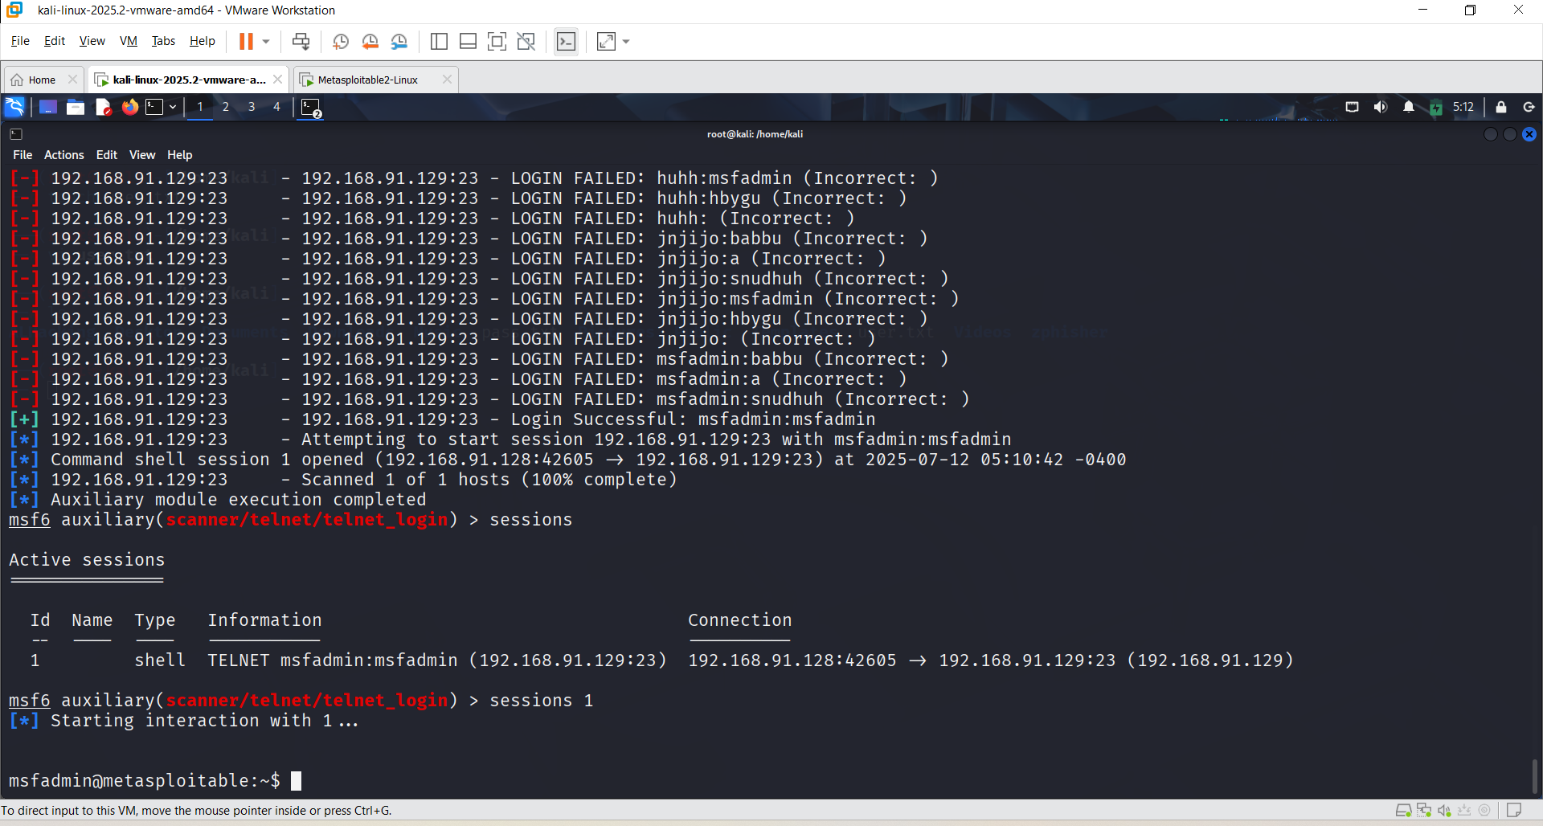

**You can observe that the file created on the Kali Linux machine is also visible on the Metasploitable system. This indicates that the attacker has successfully gained access and can view, modify, or transfer files between the two systems, demonstrating a complete compromise of the target machine.**

